**Week 09**

# **LocalStorage, sessionStorage**

Both localStorage and session Storage allow the saving key/value (object) in the user's browser, therefore we must not store sensitive or confidential data, and it's possible to find this information in Application in dev tools.

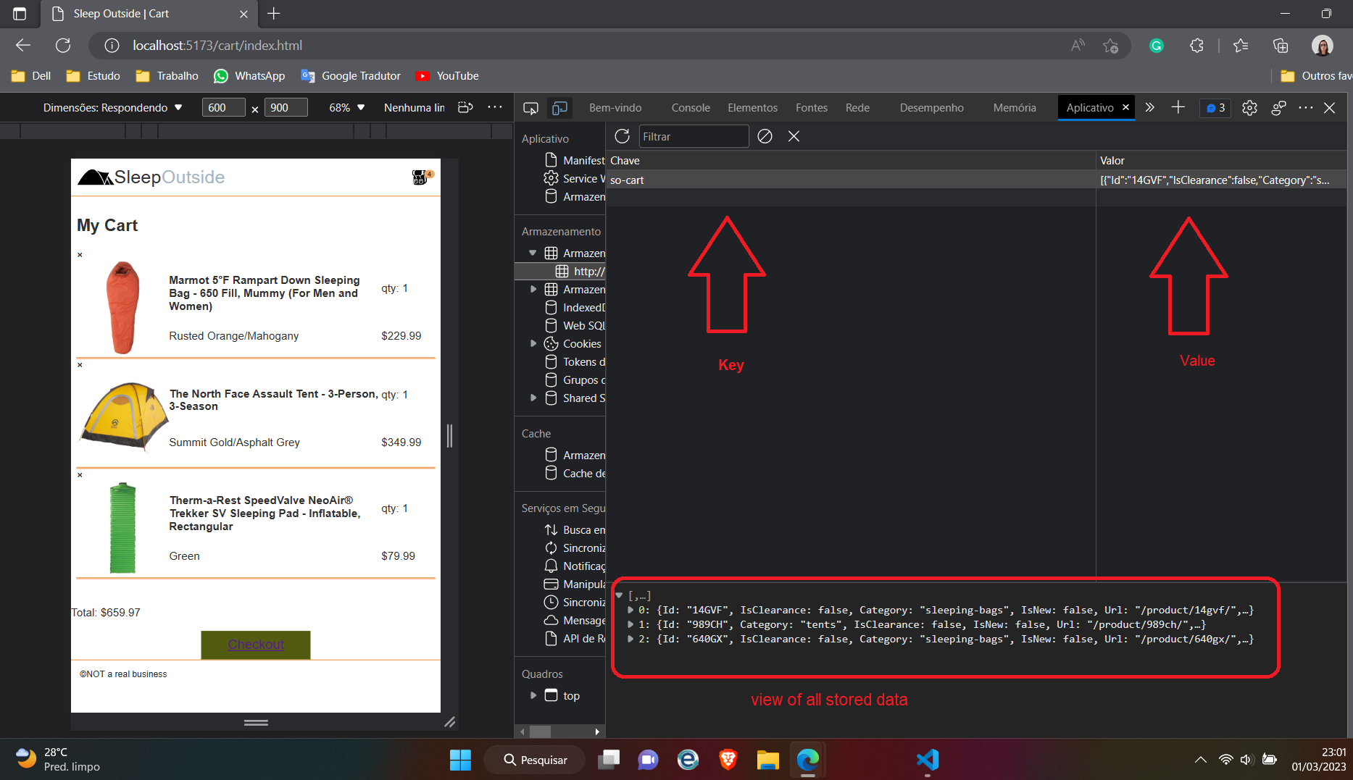

Your capacity storage is 5 megabytes.

They have the same methods and properties:

* setItem(key, value) – store key/value pair.
* getItem(key) – get the value by key.
* removeItem(key) – remove the key with its value.
* clear() – delete everything.
* key(index) – get the key on a given position.
* length – the number of stored items.

LocalStorage your data can be removed but doesn't have a time expiration and, even if to close the browser or refresh the page the object continuous there.

SessionStorage data expires when the tab is closed.

Important to remember that key/value pair need must be strings when the data is of other types is necessary to convert it to string , example:

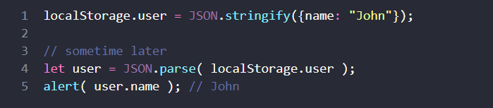

Examples of how to configure, retrieve information and make loops in localStorage or sessionStorage can be seen at the link [LocalStorage, sessionStorage (javascript.info)](https://javascript.info/localstorage#object-like-access)

**Web APIs: Drawing Graphics**

There are some tools available for using drawing graphics: Scalable Vector Graphics (SVG) and <canvas> elements in HTML, with them is possible to create 2D or 3D animations or scenes but this only happens with aid CSS and JavaScript.

To works with <canvas> is necessary to call this tag in HTML and determine your width and height that can set in HTML or JavaScript, furthermore in JavaScript file need set the position x and x that will be followed your width and height and too determine the method will use.

Example:

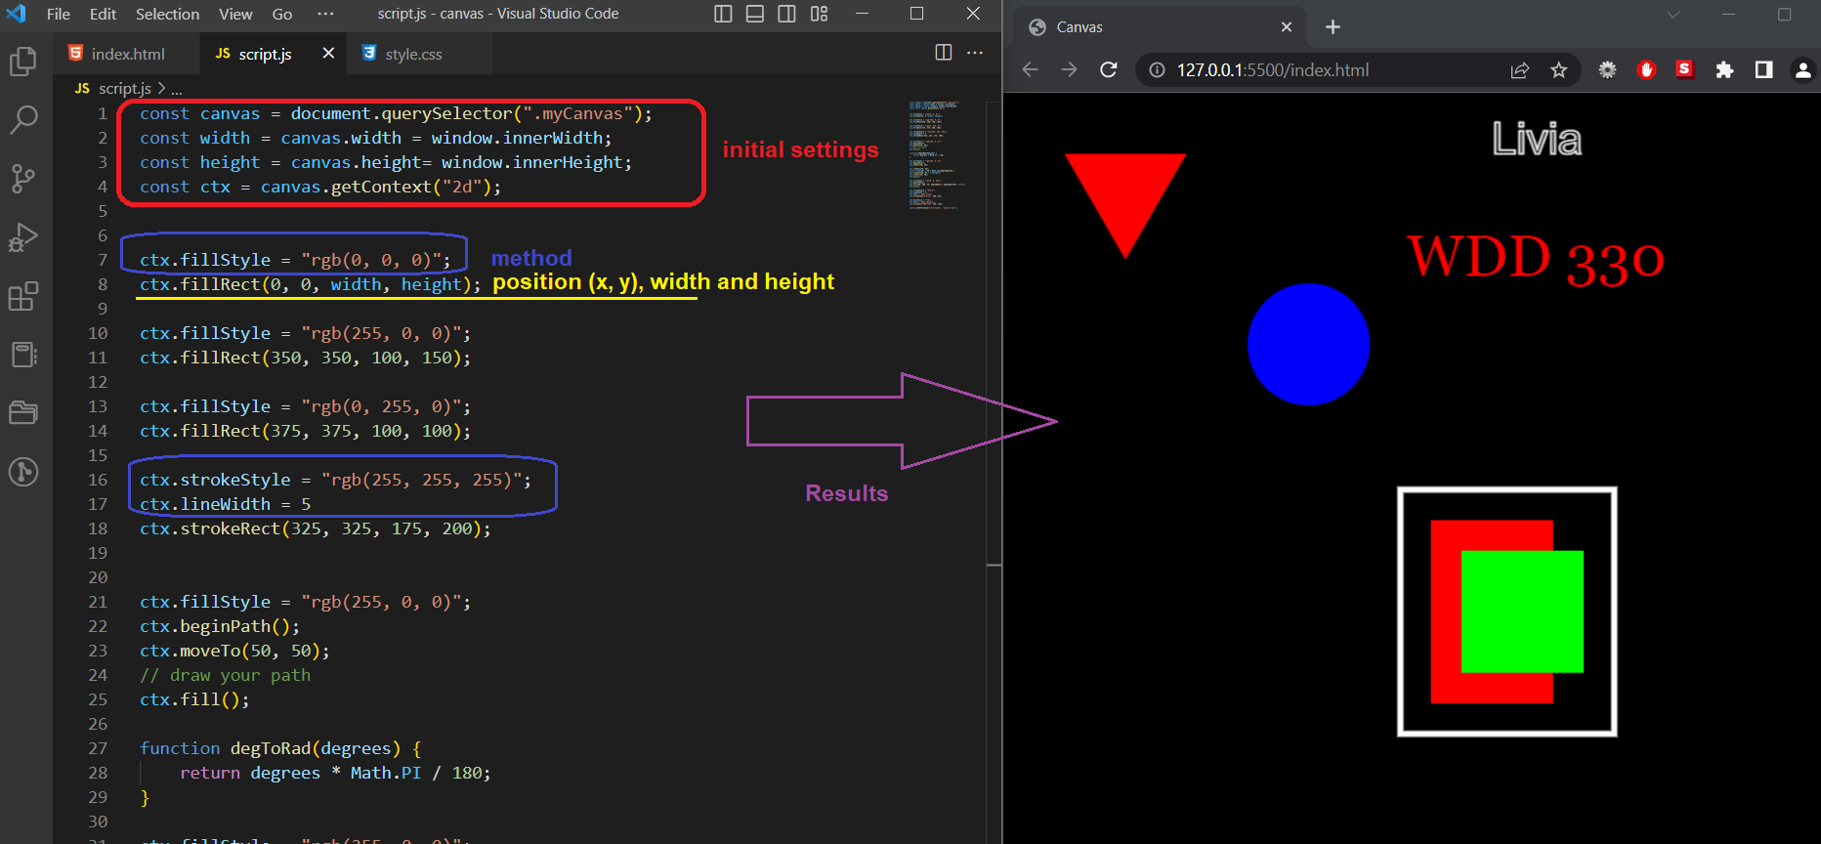

The example above demonstrated text and geometric shapes, but much more can be done like movement and loops, for more examples and explanations consult the documentation in [Drawing graphics - Learn web development | MDN (mozilla.org)](https://developer.mozilla.org/en-US/docs/Learn/JavaScript/Client-side_web_APIs/Drawing_graphics)